The Paperless Shop Floor: How Odoo’s Tablet Interface Boosts Operator Efficiency

Rohan Raj | Mar 13 , 2026

Introduction
Walk into any traditional manufacturing unit and you will find clipboards, printed job cards, handwritten time logs, and routing sheets pinned to notice boards. These paper-based systems work — until they don’t. Job cards go missing between stations, time entries are filled in from memory, supervisors have zero real-time visibility, and operators waste precious minutes at the start of every shift just figuring out what to work on next.
Odoo 19 eliminates all of this with its dedicated Shop Floor module — a tablet-optimised interface built specifically for production operators. Operators sign in, see their assigned work orders, follow step-by-step instructions, complete quality checks, and log time, all from a tablet mounted at their work center. No clipboards, no paper travellers, no manual reporting.
This blog walks through how each part of the interface directly makes operators faster, more accurate, and less dependent on paper.

What Is the Shop Floor Module?
The Shop Floor module is a companion to Odoo’s Manufacturing app. It is installed automatically when you install Manufacturing and provides a dedicated interface for operators to process manufacturing orders and work orders without ever touching the back-end.
It's basically a simple screen made just for the worker on the factory floor. They only see their tasks — nothing extra, nothing confusing. While the manager handles all the planning on a computer, the worker just looks at their tablet and sees exactly what they need to do right now.
Any update an operator makes on the tablet — marking a step complete, logging a quantity, flagging a quality issue — is instantly reflected in the manufacturing order on the back end.

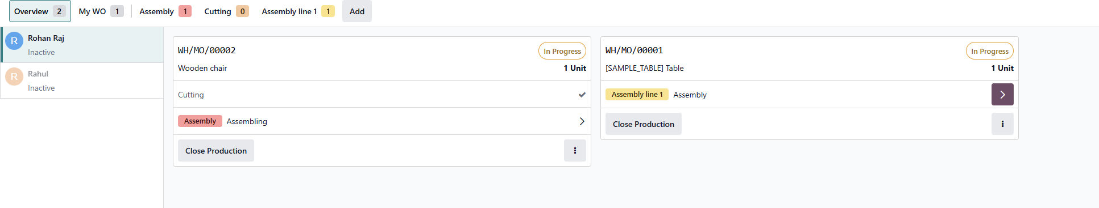

Setting Up the Shop Floor in Odoo 19

Step 1: Install the Manufacturing App
Go to Apps → Search “Manufacturing” → Click Install
The Shop Floor module is installed automatically alongside Manufacturing. No separate installation is needed.

Step 2: Enable Work Orders
Go to Manufacturing → Configuration → Settings → Enable Work Orders → Save
Without this setting, work centres and work orders are not available. This is the single most important setting to enable before you start. Shop Floor will also be enabled here automatically when you installed the Manufacturing app.
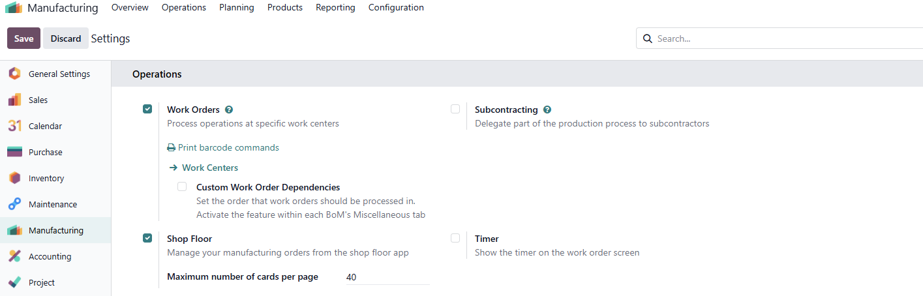

Shop Floor Interface
The Shop Floor interface is organised into three views, each view is designed to show operators only what matters to them, so there are no confusions and distractions.

Overview
The moment an operator arrives at their station, the Overview shows them every manufacturing order that is ready to start — confirmed and ordered by scheduled date so the most urgent work appears first. There is no printed priority list to check, no supervisor to ask. The screen tells the operator exactly what needs to happen and in what order.
Each card shows the product name, quantity, MO reference, current status, and which work orders are completed versus pending. The operator has everything they need before they even touch a machine.


Work Center Pages
Each work center gets its own dedicated page on the tablet showing only the work orders assigned to that station.
Each work order card shows the product, quantity, step-by-step instructions, and a Register Production line. When the operator finishes, they tap Mark as Done (if more work orders remain in the manufacturing order) or Close Production (if this is the last step). The card fades away. The next job appears.
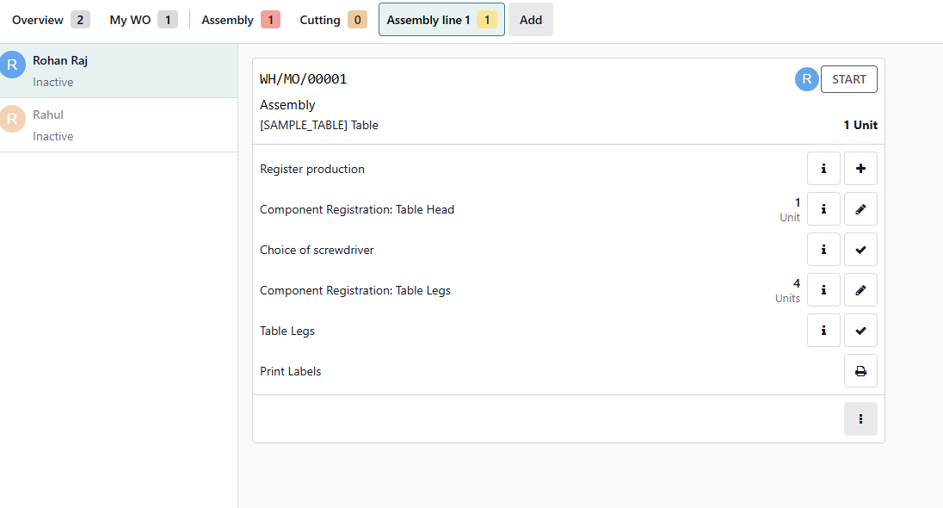

My WO
For operators who move between work centres during a shift, the My WO filters the view to show only work orders assigned to them personally. Same functionality, same simplicity — just scoped to one person regardless of which station they are at.
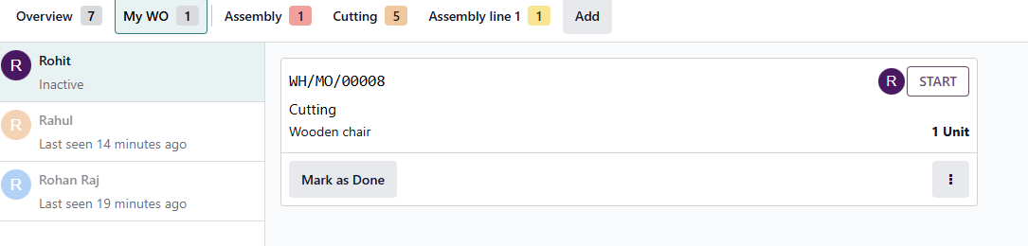

The Operator Panel: Replacing the Logbook
On the left side of the screen, the Operator Panel shows in real time exactly who is signed in or their last seen and also shows how long they have been working on it. This single panel replaces the physical shift logbook that most factories rely on for handover and attendance tracking.
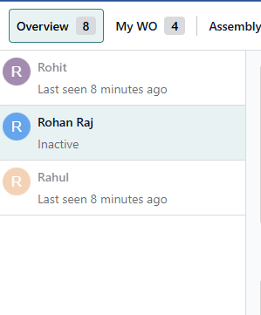
Operators sign in with a PIN code — no shared logins, no password complexity, just a quick number entry that identifies them individually for every action they take. Multiple operators can be signed in on the same tablet simultaneously, each with their own active timer and their own work order assignment.

Automatic Time Tracking: The End of the Time Sheet
The Shop Floor tablet makes time tracking automatic.
There is no time sheet to fill in. The moment an operator taps their work order to start, the timer starts. The moment they tap Mark as Done or Close Production, it stops. Their entire shift’s production time is recorded without them writing a single number
The system runs two timers simultaneously for complete visibility:
- Work Order Timer — total time spent to complete all the operations in this work order
- Operator Timer — time spent by this individual operator in their current session

All time data feeds directly into the Real Duration field on the manufacturing order, where managers can compare actual versus planned duration per work center. They can see real duration and the operator assigned for each operation.
Go to Manufacturing → Operations → Manufacturing Orders → Select MO → Work Orders tab
[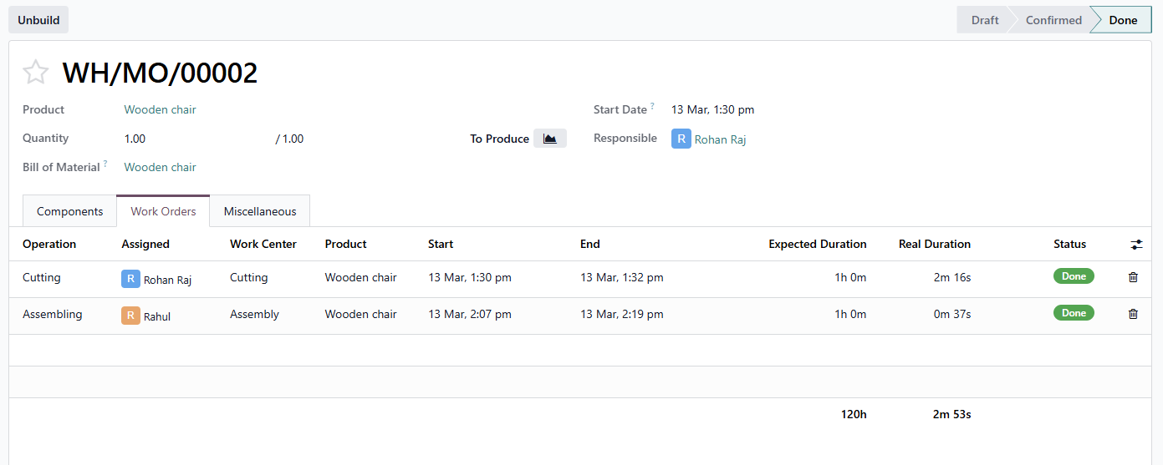

Smart Prioritisation: Always Working on the Right Thing
A printed priority list is outdated the moment it leaves the printer. If a rush order comes in, someone has to reprint, redistribute, and hope every operator sees the update before they start the wrong job.
On the Shop Floor tablet, manufacturing orders are automatically ordered by their scheduled date. The most urgent job is always at the top. When scheduling changes — a customer moves up their delivery, a machine goes down, a rush order is confirmed — the display updates in real time on every tablet on the floor simultaneously. No reprinting, no redistribution, no miscommunication.

Raising Issues Without Leaving the Station
On a traditional floor, when an operator has a problem — a machine breakdown, a missing component, an unclear instruction — they stop working and go find a supervisor. The machine sits idle. Production pauses. Time is lost just in the communication.
From the Shop Floor tablet, the operator raises a production block without leaving their station. They tap the options menu on their work order, select the reason, and confirm. The block is logged instantly with their name, the timestamp, and the reason. The relevant team is alerted immediately.
Tap work order options menu → Block → Select reason → Confirm
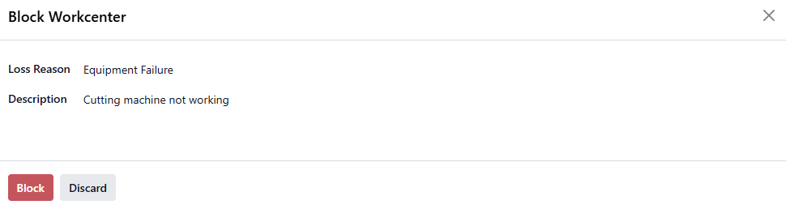

Operators can also use Suggest a Worksheet Improvement to propose changes to their on-screen instructions, or Create a Quality Alert to flag a defect to the quality team directly. Both happen in seconds from the tablet without disrupting the flow of anyone else on the floor.
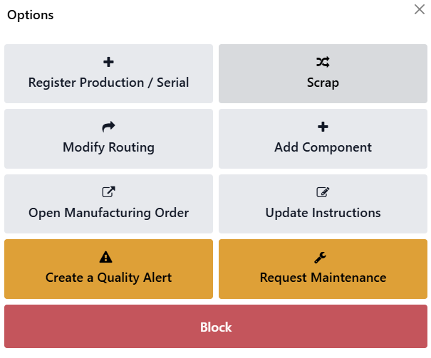

The Difference It Makes
Here is a direct comparison of how the tablet interface changes the operator’s day across the most common pain points:

Without Tablet Interface | With Odoo Shop Floor Tablet
Operator hunts for the right job card at the start of every shift | Work orders appear automatically on screen, ordered by priority
Time logging is manual, often filled in at end of shift from memory | Timer starts the moment the operator taps the work order — no logging needed
Routing sheets must be printed, distributed, and tracked down | Step-by-step instructions appear on screen per work centre
Quality checks are a separate paper form, often skipped under pressure | Quality check prompts appear inline — operator cannot proceed without completing them
Operator must find a supervisor to report a machine issue | Block raised directly from the tablet in seconds, logged with timestamp and reason
Shift handover relies on physical logbooks and verbal briefings | Operator panel shows exactly who is working on what, in real time
No visibility into how long each operation actually takes | Real duration tracked automatically per operator per work order

OEE Report
Every action an operator takes on the tablet feeds directly into Odoo’s manufacturing reports. For the first time, managers are looking at production data that reflects what actually happened — not what was estimated, not what was filled in from memory at the end of a shift.
Go to Manufacturing → Reporting → Overall Equipment Effectiveness
The OEE report shows actual production time per work centre, based on real operator timers.
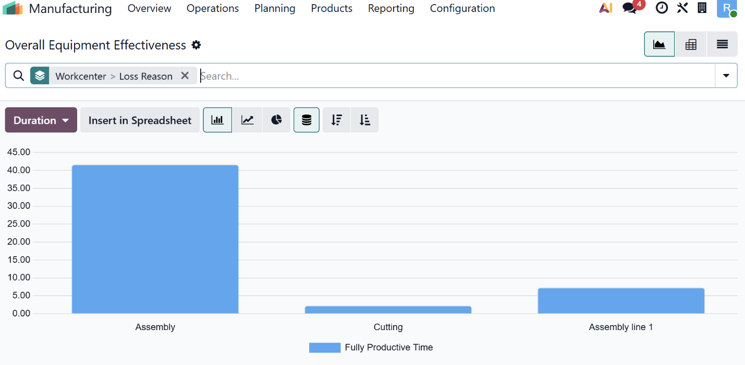

Conclusion
Going paperless on the shop floor is not about replacing one medium with another. It is about fundamentally changing how information flows through your production process. When operators see real-time work orders instead of yesterday’s printouts, when quality checks are embedded in the workflow instead of tacked on as afterthoughts, and when time tracking happens automatically instead of being scribbled on a clipboard — everything speeds up, accuracy improves, and management gets the visibility they need.
Odoo’s Shop Floor module makes this transition practical and affordable. It does not require huge cost or months of customisation. It is a built-in module that works out of the box with any tablet and a browser.

Frequently Asked Questions

1. Does the Shop Floor work on any tablet?
Yes. Shop Floor runs entirely in a web browser, so it works on Android tablets, iPads, and budget tablets alike. No native app installation is needed — just open the Odoo URL and navigate to Shop Floor.

2. Can multiple operators use the same tablet?
Yes. The Operator Panel supports multiple signed-in employees on a single device. Each operator signs in with their PIN and their time is tracked individually. This is particularly useful at work centres where two or more operators work simultaneously.

3. Can we add custom work instructions to the tablet?
Yes. You can attach PDF worksheets, images, or step-by-step instructions to specific operations in your Bill of Materials. These appear directly on the tablet when the operator opens that work order step, replacing printed instruction sheets entirely.

Ready to go paperless? As an Official Odoo Partner in India, Infintor Solutions has helped manufacturing businesses implement and optimise Odoo’s Shop Floor module across industries. Contact our team at infintor.com for a personalised demo tailored to your production environment.

